**AYDIN ADNAN MENDERES UNIVERSITY**

**ENGINEERING FACULTY**

**COMPUTER SCIENCE ENGINEERING DEPARTMENT**



**NER On Medical Text**

**CSE431 – Natural Language Processing with Machine Learning 2023/2024**

**Burak TÜZEL**

**Talha Alper ASAV**

**Lecturer:**

**Asst. Prof. Dr. Fatih SOYGAZİ**

**Named Entity Recognition on Medical Text**

**Installing necessary environment and importing the libraries:**

1. Install Jupyter Notebook

**Downloading the Medical Text:**

Here is the medical text link to download: <https://www.kaggle.com/datasets/tboyle10/medicaltranscriptions>

**Finding the Disease, Drugs and Drugs-Doses Named Entities:**

This one for “en_core_sci_sm” model:

This one for “en_core_sci_md” model:

This one for “en_ner_bc5cdr_md” model:

**Here is the Result:**

**Then We Saved the Output as .csv File So We Can Use Later On:**

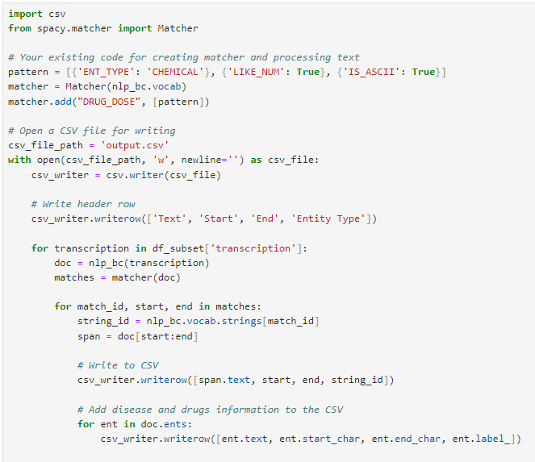

**REFERENCES**

1. <https://www.kaggle.com/datasets/tboyle10/medicaltranscriptions>
2. <https://www.analyticsvidhya.com/blog/2023/02/extracting-medical-information-from-clinical-text-with-nlp/>

ssss